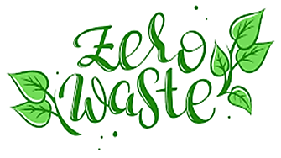

Recycle

Can We? Should We?

Tinesha N. Conway

**What is the effect of the problem?** I believe as Americans we don’t take recycling seriously. We tend to think that “someone else will always do it”. But there are many points to be taken into consideration when thinking about recycling and some of those points are:

* what are the things that need to be recycled?
* Who’s going to collect the recyclables
* where would we put the recyclables; and what processes do we need to recycle them?
* how many people do we need to do the actual recycling: from picking up, to sorting, cleaning, to actually recycling it.
* Do we give a rebate for the people who given the items for recycling? If so how much?

These are just some of the questions that need to be answered before we can get into the “actual” recycling.

One of the reasons that we need recycling is because there is so much waste in all 52 states of this country – and I say 52 states because I’m counting the Commonwealth’s as well; the Northern Marianna Island and Puerto Rico.

Let me give you an example. We use about 1,800 gallons of water to produce a cotton in a pair of jeans. To put it bluntly, the way we use water to make denim is purely depraved. It literally takes 998 gallons of water and 73 pounds of carbon dioxide to make one pair of blue jeans.

As of December 17th, 2019, The EPA estimates that in 2017, of the 16.9 million tons of **textile waste** generated in the **United States**, only 15.2% was recycled, which resulted in 11.2 million tons of **textile waste** ending up in landfills.

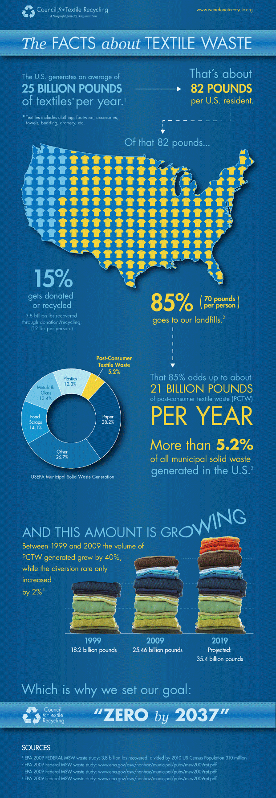We are going to look at the recycling properties of one of the worst problems of waste in the United States; and is becoming a huge problem. Clothing.

Each person every year throws away about 81 pounds of clothing every year. Now, multiply that by 331,002,651 people [that is in the entire earth] – you do the math! We have got to find a better way of dealing with the waste that we produce. Some may ask: “Well it’s not hurting anybody, right?”

Actually it is.

If we were to go vacationing to certain islands the ocean is filled with our waste, the waste that the United States throws out every year; the plastic water bottles we so frequently throw out instead of using, the plastic bags, the plastic can holders from beers and soda etc. When these products get into our water supply, the fish can eat the plastic and pollute their internal organs – this is the fish that we eat.

Then we have the clothing waste, or the leftover material after the clothing is made. We have clothes that are/have gone out of style, are now too big, too small, no longer wanted or needed – some people give them to thrift stores or concession stores.

Some people give them to shelters, but not enough of us do because we either find it too difficult to find one or too lazy to go out and look for one.

**Power Mapping**

So we’ve already discussed the problem, recycling. Clothing recycling is in itself explanatory any piece of fabric that has been thrown away that can be reused.

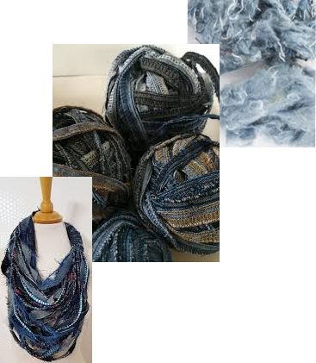Clothing by far is one of those issues that is far too wide to give a definite detailed research on some people have too much, or some people have very little and some people have just enough. Then there are those who are wasteful, some more frugal, and some who wear something one season and in the trash it goes – for far too often, as I said before, it goes into the trash. Then there are the companies that throw away the left over fabric from making items!

Now, are we looking to tackle the root cause? Yes. Yes, we are. We are tackling this problem by going to the manufacturing plants of clothing factories for companies like **Patagonia** and either purchased or are given the scraps that we then sort by color, tear them down and reconstitute them into a fiber then those fibers are then woven into material. This saves about 63 gallons of water per piece of material.

But that’s the problem with the United States and some of the people here, they are always looking for someone else to solve the problem for us instead of getting up and trying to do more to solve the problem for ourselves. People think it’s

going to be too much work or it is not really on their “to do list”. The information is there you just have to go and find it, but again this is not in the forefront of our minds it’s not thought about or even considered. Until the need becomes clear for you.

**SCAMPER**

The word scamper stands for **S**ubstitute, **C**ombine, **A**dapt, **M**odify, **P**ut to another use, **E**liminate and **R**everse.

**SUBSTITUTE**

Let’s start with the word Substitute, which focuses on product parts service or solution I can be replaced with another. One of the problems that was found with Patagonia is they don’t take recycled clothing from the average consumer. They take fabric leftovers from the company that only their clothing brand uses because, as the representative has told me, they don’t know what’s actually in the fabric and or fabric fill from other companies.

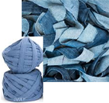

So, I’m going to have to make my own company called Nicky, New York; where I would need at least two vans, a schedule, locations where I can pick up donations of specific brands – because I now see from Patagonia, that having materials that cannot be recycled is definitely a waste.

One of the main items that I would use would have to be Jeans and anything made from Jean material but it would have to be from specific companies like Levi’s, Gap, Wrangler, Diesel, Lee, True Religion, Calvin Klein and Armani jeans. We will take anything that has a tag on it that says it is 100% cotton and/or 100% polyester and 100% plastic. We would also need a recycling center – we could use a recycling center that has been closed because of Covid and/or rent space from a recycling center that deals with clothing.

Some of the things that we could make from these materials would be thread from the polyester and plastic; from the Jean material we keep make half inch to 1 inch strips that could be used for crocheting, sewing, used in projects, making jewelry, etc. we could also use the Jean material for patches, for quilting, patching of jeans, sewing and or we can make products from the actual Jean material: handbags, hats, jackets, etc. with the 100% cotton and/or polyester, we can make threads, yarn, new fabric.

Any other material other than 100% denim, cotton, polyester would not work because of properties in the material; as far as degrading, fireproofing, durability, etc.

Because I am recycling these materials I would use less water [except for those materials that I am breaking down and having to remake into a new material and/or washing material] there will be less water used in recycling these materials.

Another question I can ask myself is can I use this idea for other materials? I believe the answer will be yes, as long as the material was 100% and met the same standards that the cotton and the Jean materials did. The reason why I did mention the polyester and or plastic is because those materials don’t degrade so easily so those materials would be used to make ropes, jewelry, shopping bags – not the ones you get from the grocery store I mean shopping bags you can reuse.

Another question I need to ask myself is **can I change my feelings or attitude towards this project?** I believe I could, but I don’t think I will because my feelings for keeping this earth happy and healthy is strong within my heart. The only part of my feelings I think would change would be how I can get things done better, faster and more efficient.

**COMBINE**

One of the first questions you need to ask yourself is: **what would happen if I combine these products with another?** Such as, if I combined the Jean material with the plastic material? Or if I combined Jean material with the polyester material? Well for one, you get a stronger material. This has been done already; that’s where we get stretchy jeans from; jean material mixed with polyester.

As stated in craftchined.com:

**“Fabrics and threads made of this plastic are used widely in apparel, home furnishings, and in commercial applications. Some examples include blankets and hats, bed sheets, and computer mouse pads. Industrial polyester fibers are made into ropes, safety belts, tire reinforcements, and conveyor belts**.”

That is what basically polyester is, it’s a form of plastic.

**What ideas, materials, features, processes, people, products or components can I combine?** Materials can be combined as mentioned earlier to form a new material – a stronger material.

The features of these combinations would be again stronger material base, longer-lasting material and this would give way to better color quality because with the stronger material depending on what it’s made from could give more elaborate colorings and make for wider product base.

As far as people go as time went on I knew I would have to get more employees to: make the products, sort the products, destroy the products, refurbish the products, collect the products; design: flyers, business cards, websites, etc.

**What can I combine so as to maximize the number of uses?** I can combine the polyester with the denim to make a thread. I can leave the denim as normal thread and or make a denim yarn by combining it with the cotton. I can also combine jeans with some type of wood feature such as paper/newspaper to make paper from jeans and/or cotton.

**How could you combine talent and resources to create a new approach to this product?** First I’d have to find the right people to work with; get people with multiple skills, such as sales people who know the product and know how to make the product and can answer any questions that a customer may have about the product. These people would also have to know how to make the product, packaged product and drive so that the packages can be delivered to wherever they need to go.

**Adapt**

**How could you adapt or readjust this product to serve another purpose or use?**  I would make pillows—decorative pillows; coin purses, toys for dogs, dog leashes and collars and face masks.

**What else is your product like?** This product is like most other products that are similar—such as yarn and/or ribbon.

**What other products/ideas could you use for inspiration?** As stated previously, I can make paper with different textures, weights and designs—but I must make sure the paper is strong enough to be handled, written on and folded. I could make small diary and text books with beautiful pens and Charms for bags. Nothing would ever come out the same, everything would be unique and I would sell certain items on certain days.

**Modify**

**How could you change the shape, look, or feel of your product?** It all depends on what kind of materials I get and how the washing, cutting and handling of the materials help the material to look or feel different.

**What could you add to modify this product?** I could add bleach, coloring and lint balls to give it a certain look.

**What could you emphasize or highlight to create more value?** The packaging, tags, bags and tissue paper would put it over the top. I could also explain on the website as well as any tags or print directly on the packaging so as not to waste products.

**What element of this product could you strengthen to create something new?** The ideas that come from my team—how my team and I can strengthen the look, the purpose of many items and how to replicate and not raise costs that raise the cost of the product itself.

**Put to Another Use**

**Can you use this product somewhere else, perhaps in another industry?** The only industry I can think of would be rope making.

**Who else could use this product?**  Gardening gloves. Pot holders and coasters for cups.Instead of making these products we can sell the ground up pieces that you use to make the products.

**How would this product behave differently in another setting?** We would have to do product testing to see if there were different uses for one or more products—an example would be when they invented Viagra for the heart and found that it helped another member of your body.

**Could you recycle the waste from this product to make something new?** Actually there would be very limited waste from these products bc we are recycling and everything gets used.

**Eliminate**

**How could you streamline or simplify this product?** Packaging. Not having unnecessary packaging.

**What could you understate or tone down?** The waste that would come from all products—we would even use the zippers from the pants, either on the purses or make jewelry from you.

**How could you make it smaller, faster, lighter, or more fun?** We could make the materials more fun by adding glitter thread, sparkles or paint to whatever we are making.

**What would happen if you took away part of this product? What would you have in its place?** The only thing I can think of are the white jeans in September-October; I would replace them with cream colored jeans or I would dye white jeans with a very light coffee tint and make something.

**Reverse**

**What would happen if you reversed this process or sequenced things differently?** Lots of things could happen. Everything has a process of doing things in a certain order. Sometimes if one thing is not done before the other, things can get lost, broken, stolen or misplaced.

As far as the app goes, the app would [at first] not be used to buy things from, I would use it to change the locations to when the truck is going to be there to pick up clothing used to make items and when it will be there to sell items. It is basically an informational app.

Possibly in the future, you will [or should] be able to buy an item you like off the website with a credit card and then come to the truck to pick it up as well as buy directly off of the truck. And later we can ship it to you.

**What if you try to do the exact opposite of what you're trying to do now?** The items would either go into the landfill or stay in the thrift/concession store until someone buys them.

**What roles could you reverse or swap?** I could retrieve the items differently, such as going to the thrift stores and buying some jeans at $5 a piece; buying T-shirts at $2.00 a piece and making several different items with them and selling them for higher prices.

**How could you reorganize this product?** The packaging on the products; I could use less packaging and use tissue paper to wrap the products instead of using plastic. We could also use paper bags instead of plastic.

**Minimal Viable Product.**

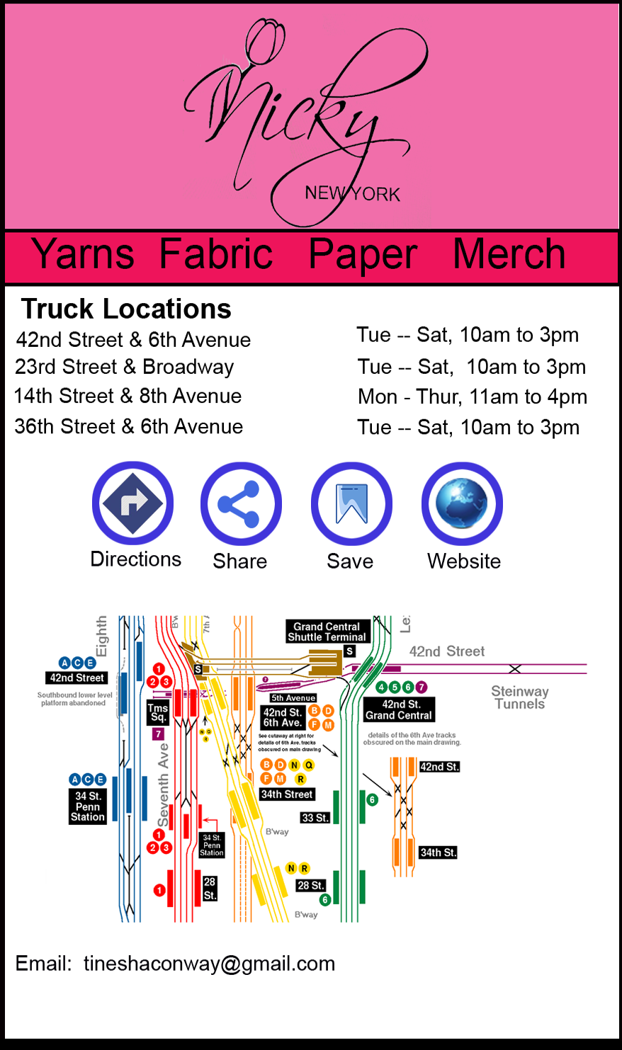

Cell Phone App for

Nicky, New York

**Lean Business Model Canvas**

**What is the problem you are looking to solve?** Basically getting good quality inventory for next to nothing—what if I go to every thrift store in all five boros and all of them have run out of the quality jean, cotton or polyester material I need? Do I go to the fabric stores and pay for quality material at fair market prices? Can I contact the processing plants located here in the tristate area—will they even talk with me? If they do, will they sell to me for pennies on the dollar, even though they were throwing away the material? Or will they take a tax break by just giving it to me?

This is where having good negotiating skills comes into play.

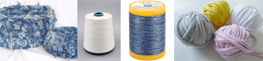Most jean places also make T-shirts; will I have access to those as well? Is the material 100% cotton or is it mixed? These are questions I have to have answered.

**Who experiences this problem and is likely to use your solution (Who is this for?)?** Many companies have this problem, especially as a company, you are caught between a rock and a hard place when it comes to getting the prices they need for inventory. You have to pay not only for your selection per piece or per pound; but also for taxes, shipping and any other fee that the person supplying you with the material feels s/he ‘thinks’ they are entitled to.

**What is our MVP solution to this problem?** The solution is to not rely solely on these companies that have throwaway material. You’re going to have to find people who are willing to work with you to help this company grow; that means going to all the little back alley places in New York City that have tons and tons of clothes that they sell by the pound, go to every thrift shop store in New York City and let them know that if they have a name brand 100% denim Jean jacket or even shirt to pay their top dollar for it.

This way, keep the prices low enough that people will come back, but high enough that you can pay the people who work for you.

**How will we know if our solution is effective?** You’ll know that your solution is effective at say after month six or seven, this way you have a better idea of where your inventory is going to come from, how to get it, what the pickup dates will be, what companies will work with you, which will not.

You also have a better idea of what your personnel going to be like; can they produce absolutely fabulous ideas? Are they lazy? Who’s willing to work, or who’s in it to steal from you – your ideas, your business plan and who’s willing to move forward with you to help you make this company grow?

You also have a better idea of how much money is coming in so you know whether or not to get more trucks; have longer/shorter time frames in each neighborhood; you get a better idea of how much inventory you should keep in the truck – whether or not you should carry cash or just use credit cards instead of carrying both or should you always have both?

**What makes our solution different from other solutions solving the same problem?** I don’t think it’s a solution to a problem, I think this particular niche is going to be like everything else especially here in New York where one person comes up with an idea to do something new and you have 20 companies after you try to piggyback off what you’re trying to do and copy you.

Now don’t get me wrong it’s not so much a solution this company. It’s more of a let’s try and find a way to use something that’s being thrown away anyway. And there are many companies out there that do do this – in this particular way? Maybe not.

So I think it’s not so much a solution about solving the same problem I think it’s a solution on how do you stay ahead of other companies coming up behind you trying to do the same thing – because when your niche, and it’s a good niche, people always want to ride your coattails. And that’s what I meant before about making sure you hire the right people because I’ve seen time and time again in different companies where employees would get mad because “their idea” wasn’t being used and they go off and create another company doing the exact same thing except now they’re able to use their idea.

That’s money out of your pocket, one because they may have taken some of your customers and some of your employees and also they’ve taken some of their ideas along with them.

**How will we get our solution into the hands of those that can use it? Will it be downloaded/is it free? Will you need to train people on how to use it?** I think we will do this the old fashioned way at first—word of mouth and flyers in the windows of thrift stores, fabric houses, schools and the schools are where I can get some of the talent from as well.

I can go to talk to companies that rid themselves of the fabric, talk to sewing houses that will allow me to use their sewing rooms for a couple of hours or days a week.

As we grow and know where our company is going, then we can start on the website, create it, get the van, make sure we have enough inventory and on the van what we will do, have, sell and hopefully break even in the first two days we’re out there.

There won’t be any training on how to use the website—it will be just informational for now, later, you will be able to pre-order and get it sent to you or you can come and pick it up when our van is in the area. We will only be dealing with Manhattan first; and then we will add Queens and Brooklyn to reach further.

**Is there a factor that makes your solution more effective than other solutions by the nature of a structural advantage either of the product or of your team (for example, do you have access to data that others don’t?)?**

You know, that’s a good question. My solution again isn’t new and or it is it more effective it’s just different. I don’t think I have an advantage over anyone else in the design business except for startup costs. And now anyone can get to the data that is needed to get this or any other business started either from:

* Business Library,
* Talking to People,
* SCORE, Service Corps of Retired Executives,
* Finding a mentor
* Finding an Investor

The last one is for people who own a business already, and if they allow you to, get into their mindset find out what it is you really need to make your business grow and to stay in business.

For instance, right down what is actually going on in this situation with the Covid 19 and keep a diary for what you want to do, what’s stopping you, how, where, how much and what you have to spend as far as your money goes.

Where can you get money from? What deals can you get now as compared to back when – meaning six months to a year ago. Find out who owns a sewing house and asked him if they allow you to use their space rent free or for a reasonable fee for about two months and you can either pay them or do some work for them to pay the rent—barter.

Some of the best companies in the world have started off with simple and economical ways. A lot of people have forgotten that, especially during these type of times; now, we have to go back to things like bartering and making deals if some of us want to survive.

**What is the base cost it takes to create and maintain your solution? What is the cost of serving one person? The 100th person? The 1000th person?**

One of the two things that are needed when starting a business of this kind is a business plan/synopsis and a truck. Writing a business plan is the most vital and important part of starting any type of business. You also want to have a synopsis so that when you go down to the banks or you want to show someone you’re trying to get advice and or money from you have a structured and shortened version of your business plan, which is the synopsis, to show so that they know you’re serious about what you’re about to do. Also carry the full business plan with you just in case they ask is this all of it you say no, here’s the full version of the business plan I’m just giving you the synopsis so that you can get an idea of what I’m trying to do.

The most expensive is a truck next going down the list is inventory. When buying a truck, you have to have a mechanic look at it from an unbiased opinion at what exactly is/isn’t wrong with it.

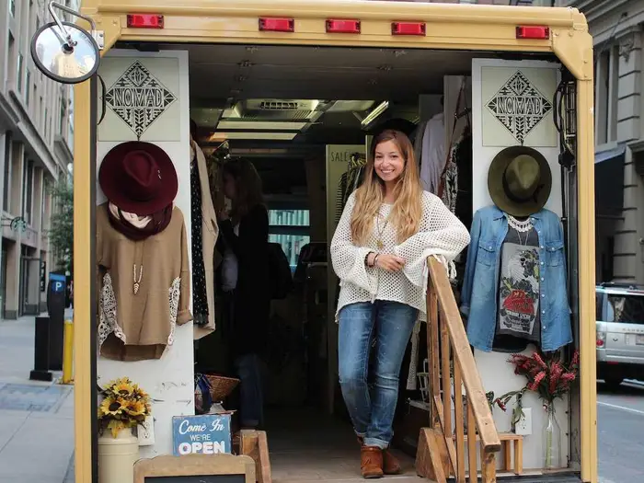

**Jessie Goldenberg poses in the entrance of her fashion truck called Nomad.**

Finding an investor would have to come next on the list because without any money [unless you already have some] your business is going nowhere. Do your homework, talk to people, find out what they’re asking for, what they need from you as far as interest rates, duties or liability.

Most people like myself, don’t want investors because they tend to bring a little bit more of a headache to the equation rather than a help. Sometimes with investors you feel like you are borrowing money instead of having full control over what you are doing – some investors actually want control over some of your ideas – that basically is me but, it is a thought.

[Nomad](http://thenomadtruck.com/) is just one of trucks that the [American Mobile Retail Association (AMRA)](http://americanmobileretailassociation.blogspot.com/) tells us is approximately 500 fashion trucks spread across all 50 states. They began popping up in 2010, but the trend has exploded in the past year as new entrepreneurs learn from the successes and failures of the past and present owners.

Here is a listing of the items you would need in order to get your business, if you starting the type of business that I am:

* If you’re a current or aspiring vendor, please **join** our [**Facebook group**](https://www.facebook.com/groups/788552354501688/), and get in touch at (773)834-3129 or

[**streetvendorsjusticecoalition@gmail.com**](mailto:streetvendorsjusticecoalition@gmail.com).

* Getting involved with the **American Mobile Retail Association, AMRA** is also a great way to help you get started because it could help you avoid some delays, fines, crazy fees and headaches one would find with no help.

**How will your solution make revenue so it is able to fund itself and consistently provide the service?**

By first selling items such as yarns, ribbons, patches, threads; if we can we will also sell small, medium and large sheets for quilting in all the shades of the jean material: white, black, light, medium and dark blue.

Then we can start on making papers in 5, 10 and 20 packs of paper. Making hats, bags, shawls, jewelry: necklaces, bracelets and earrings. And next comes why I need special people to help me to come up with ideas and new inventory.